PRACTICAL 1

Name : Ranudi Gayathmie Kariyapperuma
Index : 29897
Batch No : 23.1
Degree Program Name : Technology Management

- #include <stdio.h>

int main()
{
printf("Ranudi Gayathmie Kariyapperuma \n");
printf("Sujatha Vidyalaya Nugegoda \n");
return 0;

}

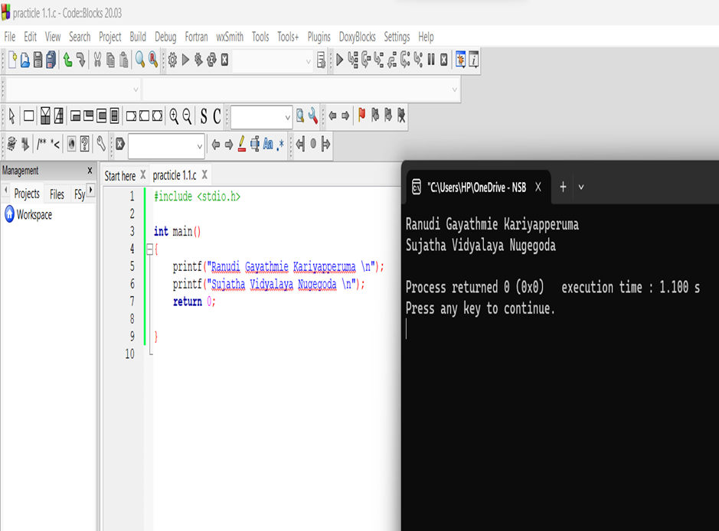
2 #include <stdio.h>

int main()
{
printf("*\n");
printf("**\n");
printf("***\n");
printf("****\n");
printf("*****\n");

return 0;
}

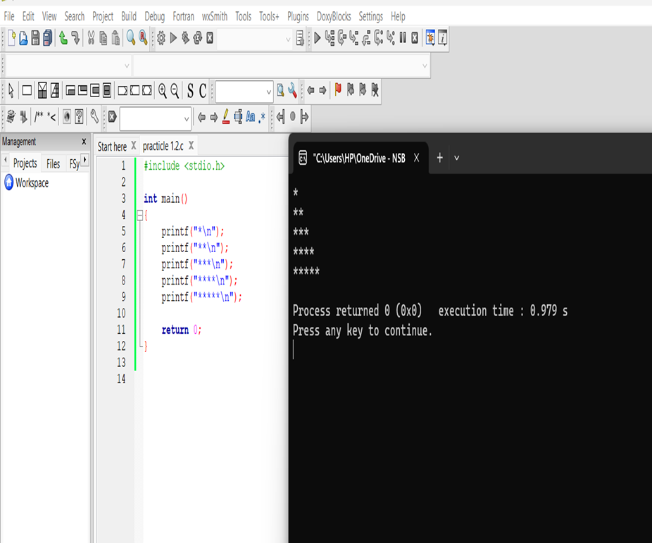

- #include <stdio.h>

int main()
{
int inte = 5 ;
float flo = 4.5 ;
char charact = 'A';
double doub = 5.6 ;

printf ("integer = %d\n",inte);
printf("float = %f\n",flo);
printf("character = %c\n",charact);
printf("double = %f\n",doub);

return 0;
}

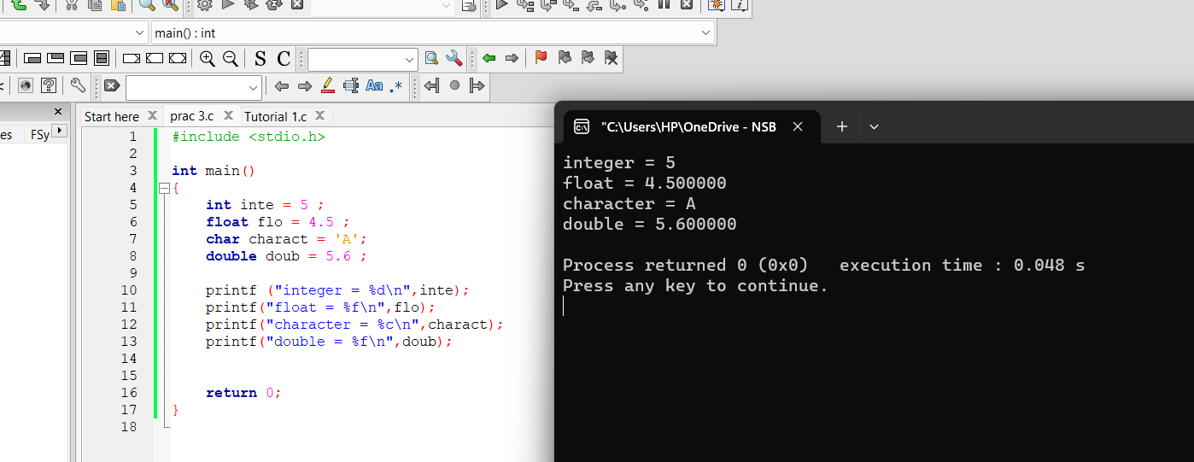

- #include<stdio.h>

int main()
{
int num1,num2,total;
printf("Enter number:");
scanf("%d",&num1);
printf("Enter number:");
scanf("%d",&num2);

total = (num1+num2);

printf("%d + %d \n",num1,num2);
printf("Total = %d \n",total);

return 0;
}

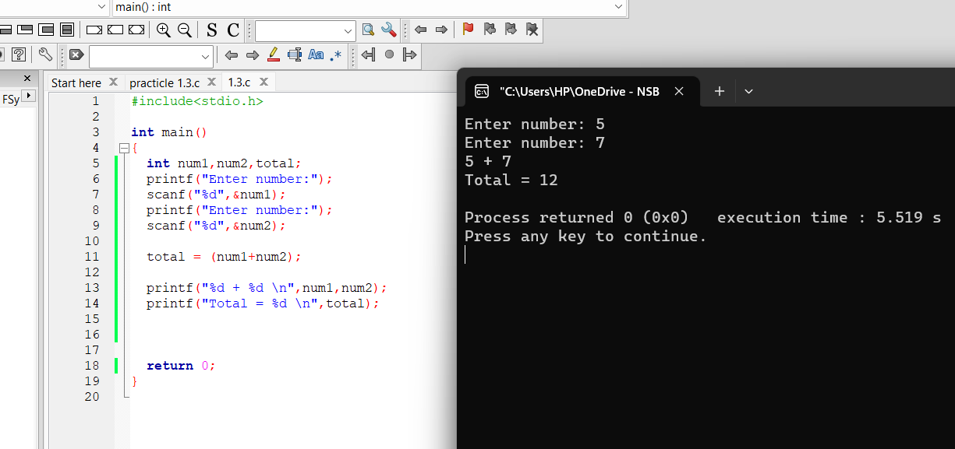

5 .#include<stdio.h>
int main()
{
int num1,num2,Total;
float Average;

printf("Enter First Number:");
scanf("%d",&num1);
printf("Enter Second Number:");
scanf("%d",&num2);
Total = (num1+num2);
printf("%d + %d \n",num1,num2);
printf("Total = %d \n",Total);

Average =(Total/2);
printf("Average is %f ",Average);

return 0;
}

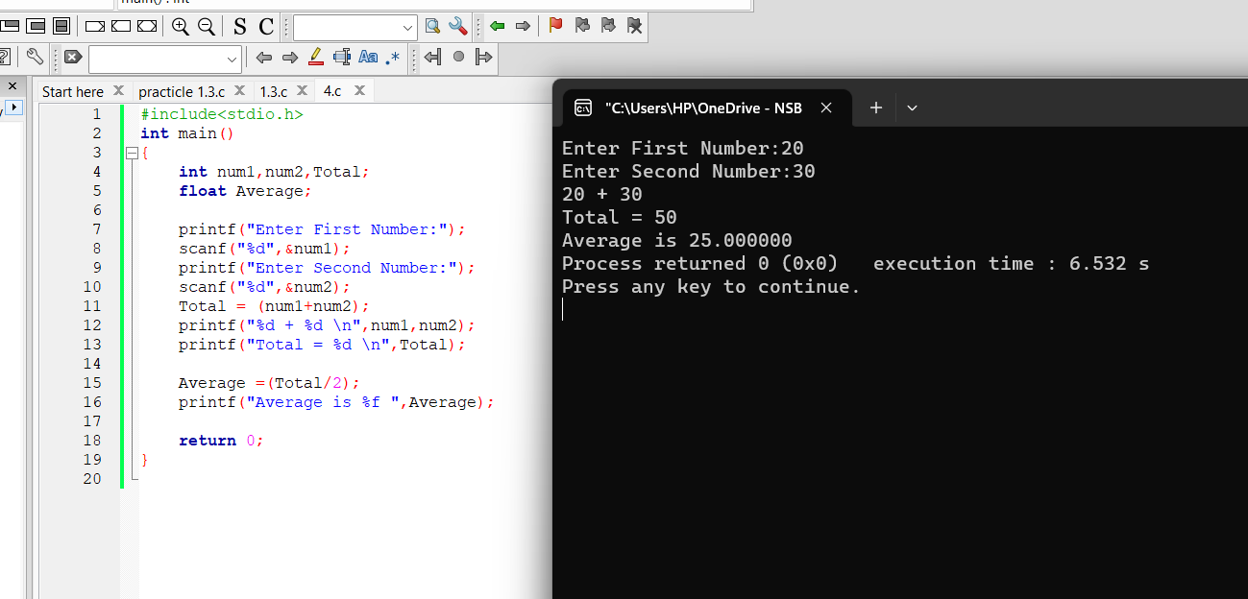

- #include<stdio.h>
int main()
{
char Name[50];
int birthyear,currentyear,Age;

printf("Enter Your Name : ");
scanf("%s",&Name);
printf("Enter Your Birth Year : ");
scanf("%d",&birthyear);
printf("Enter Current Year :");
scanf("%d",&currentyear);
Age = (currentyear-birthyear);

printf("Name is %s and Age is %d \n ",Name,Age);

return 0;
}

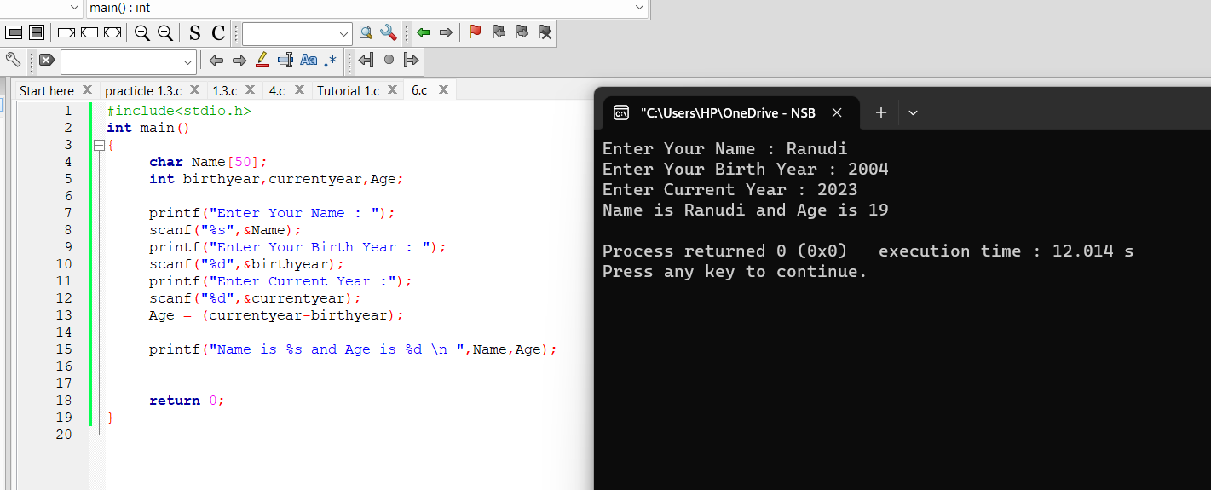

7 . #include<stdio.h>
int main()
{
int no1,no2,no3;

printf("Enter First Number :");
scanf("%d",&no1);
printf("Enter Second Number:");
scanf("%d",&no2);

no3 = no1;
no1 = no2;
no2 = no3;

printf("After Swapping First Number : %d \n",no1);
printf("After Swapping Second Number : %d \n",no2);

return 0;
}

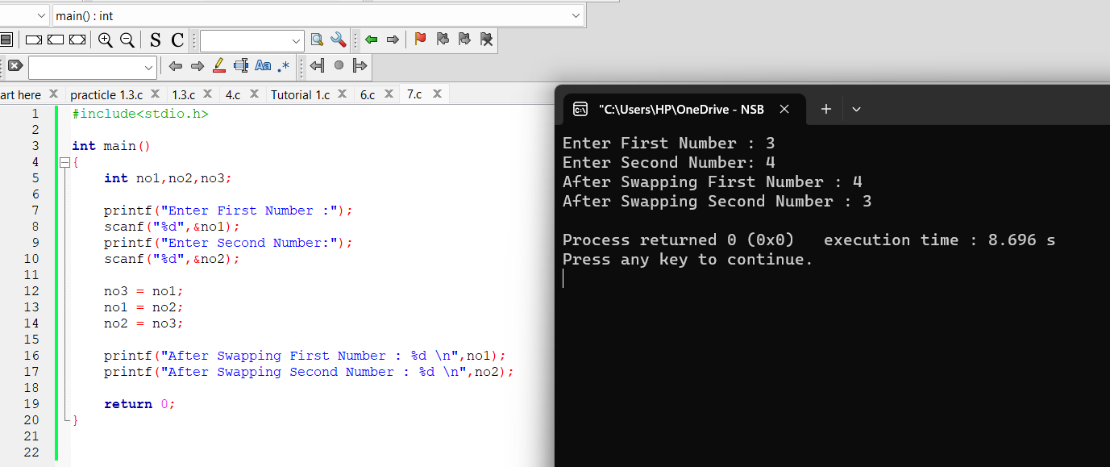

- #include<stdio.h>
main()
{
printf("The color: %s\n", "blue");// "%s"shown as "blue"value

printf("First number: %d\n", 12345); // "%d" shown as"12345"value

printf("Second number: %04d\n", 25);//Output shows Four values

printf("Third number: %i\n", 1234);//Output shows the same value that enterd

printf("Float number: %3.2f\n", 3.14159);//This float number limits 2 decimals

printf("Hexadecimal: %x\n", 255);//show the Hexadecimal value of 255

printf("Octal: %o\n", 255);//show the octal value

printf("Unsigned value: %u\n", 150);//show the value same as the input

printf("Just print the percentage sign %%\n", 10);// show the % mark
}

